Mechatronics and Industrial Internet of Things

IIoT-Based Water Level Detection and Flood Alert System

PROJECT REPORT

BHAVESH PRAKASH G - 24MER005
VASANTHAN B – 24MER060
PRABHUKUMAR N – 24MER40
AJAY PRABHAV A – 24MER003
SANTHAKUMAR M – 24MEL065
DEEPAK C – 24MEL069

- Project Overview:
The Water Level Detection and Flood Alert System using an Ultrasonic Sensor is a safety and monitoring system designed to measure the water level in tanks, rivers, canals, dams, and other water-storage or water-flow environments. The system uses an HC-SR04 ultrasonic sensor to determine the distance between the sensor and the water surface without requiring direct contact with the water.
The measured distance is processed by an Arduino Uno microcontroller. Based on predefined water-level limits, the system classifies the condition as Normal, Warning, or Critical. LEDs and a buzzer provide immediate visual and audible alerts when the water level approaches or exceeds the danger limit. This prototype demonstrates a low-cost method of continuous water-level monitoring and early flood/overflow warning. The system can later be extended with GSM, Wi-Fi, IoT dashboards, solar power, and cloud-based monitoring.

- Project Statement:
Flooding and water overflow can cause serious damage to human life, agricultural land, infrastructure, vehicles, and property. Conventional water-level monitoring methods often depend on manual inspection or simple mechanical indicators. These methods may not provide continuous monitoring and often require human presence for observation. Sudden increases in water levels may not be detected quickly, and immediate warning alerts may not be available.
The main problems addressed by this project are:
- Continuous monitoring is difficult.
- Manual observation requires human presence.
- Sudden increases in water levels may not be detected quickly.
- Conventional systems may not provide immediate warning.
- Direct-contact sensors can suffer from corrosion and contamination.
- Remote locations such as dams and rivers are difficult to monitor manually.
Therefore, there is a need for a low-cost, non-contact, automatic water-level monitoring system that can continuously measure water level and generate an early warning when the water reaches a dangerous level.

- Proposed Solution:
The proposed Water Level Detection and Flood Alert System uses an HC-SR04 ultrasonic sensor, Arduino Uno, LEDs, and a buzzer to continuously monitor water levels in tanks, rivers, canals, dams, and other water-storage environments. The ultrasonic sensor is mounted above the water surface and operates as a non-contact measuring device. It transmits ultrasonic waves toward the water surface and receives the reflected waves. The Arduino Uno measures the time taken for the waves to return and calculates the distance between the sensor and the water surface.
The system performs the following functions:
- Continuously measures the distance between the sensor and water surface.
- Calculates the actual water level using the measured distance.
- Monitors water level in real time.
- Classifies the water condition as Normal, Warning, or Critical.
- Provides visual indication using LEDs.
- Generates an audible alert using a buzzer during critical conditions.
Using the measured distance and the known height of the tank or channel, the system determines the actual water level. The calculated water level is continuously compared with predefined threshold values to identify the current condition. When the water level is below the warning limit, the system indicates a normal condition by activating the green LED. As the water level rises and enters the warning range, the yellow LED is turned ON to alert the user. When the water level exceeds the critical limit, the red LED and buzzer are activated to provide an immediate flood or overflow warning.
The system provides continuous real-time monitoring and enables early detection of potentially dangerous water levels. Since the ultrasonic sensor does not come into direct contact with water, issues such as corrosion and contamination can be minimized. The prototype demonstrates a simple, reliable, and low-cost solution for water-level monitoring and flood-alert applications. It can also be extended in the future with Wi-Fi connectivity, IoT dashboards, cloud-based monitoring, GSM-based alerts, and solar-powered operation for enhanced remote monitoring and smart water-management systems.

- System Architecture:

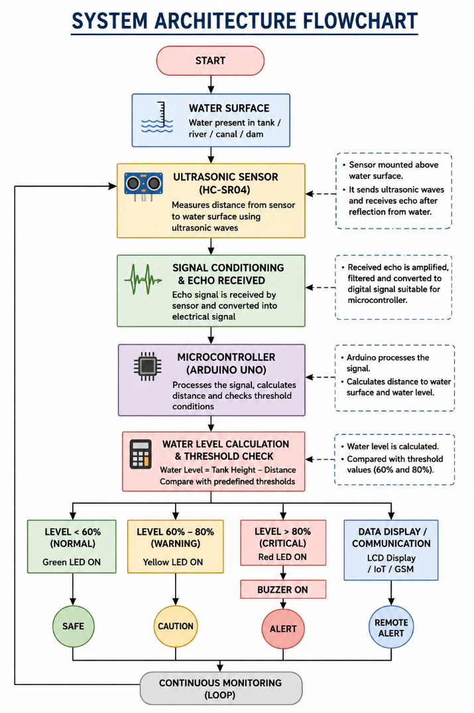

- Circuit Table:

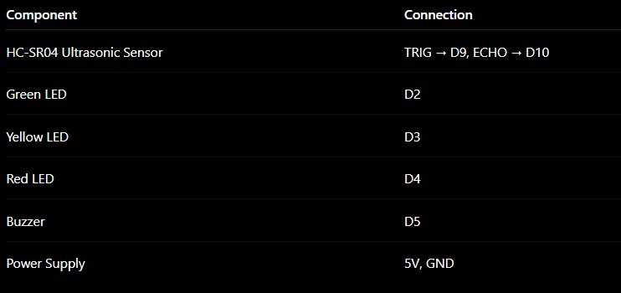

- Circuit Design:
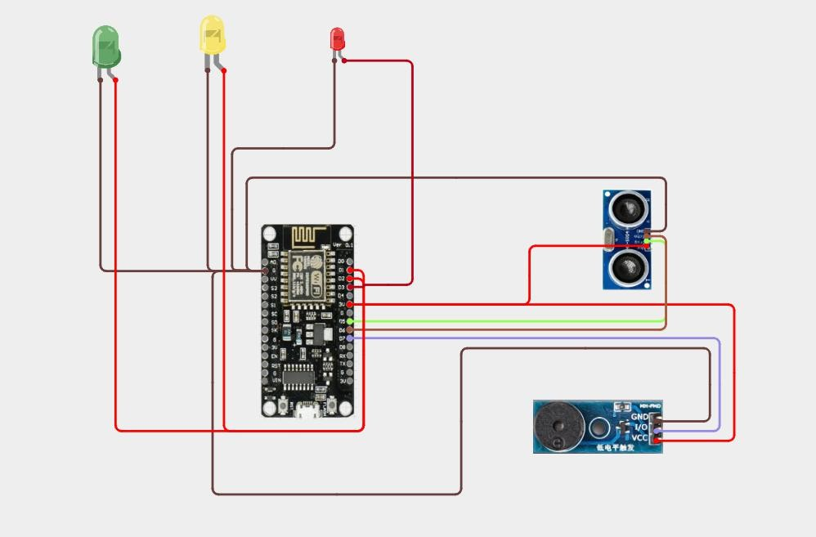

- Algorithm:
Step 1: Start the system.
Step 2: Initialize the Arduino Uno and HC-SR04 ultrasonic sensor.
Step 3: Measure the distance between the sensor and water surface.
Step 4: Calculate the water level percentage.
Step 5: Compare the water level with predefined threshold values.
Step 6: If water level < 60%, turn ON Green LED (Normal).
Step 7: If water level is between 60% and 80%, turn ON Yellow LED (Warning).
Step 8: If water level > 80%, turn ON Red LED and Buzzer (Critical).
Step 9: Display the current water-level status.
Step 10: Repeat the process continuously for real-time monitoring.

- Coding:
/*****************
Water Level Detection & Flood Alert System NodeMCU ESP8266
*****************/

#include <ESP8266WiFi.h> #include "AdafruitIO_WiFi.h"

// WiFi Credentials
#define WIFI_SSID "YOUR_WIFI_NAME" #define WIFI_PASS "YOUR_WIFI_PASSWORD"

// Adafruit IO Credentials
#define IO_USERNAME "YOUR_ADAFRUIT_USERNAME" #define IO_KEY "YOUR_ADAFRUIT_KEY"

AdafruitIO_WiFi io(IO_USERNAME, IO_KEY, WIFI_SSID, WIFI_PASS);

// Adafruit IO Feeds
AdafruitIO_Feed *waterLevelFeed = io.feed("water-level"); AdafruitIO_Feed *distanceFeed = io.feed("distance"); AdafruitIO_Feed *statusFeed = io.feed("status");

// GPIO Pins
#define TRIG_PIN 14 // GPIO14 (D5) #define ECHO_PIN 12 // GPIO12 (D6)

#define GREEN_LED 5 // GPIO5 (D1) #define YELLOW_LED 4 // GPIO4 (D2) #define RED_LED 13 // GPIO13 (D7)

#define BUZZER 15 // GPIO15 (D8)

// Tank Height
const float tankHeight = 100.0; // cm

bool alertSent = false; unsigned long lastUpload = 0;

void setup() {

Serial.begin(115200);

pinMode(TRIG_PIN, OUTPUT); pinMode(ECHO_PIN, INPUT);

pinMode(GREEN_LED, OUTPUT); pinMode(YELLOW_LED, OUTPUT); pinMode(RED_LED, OUTPUT); pinMode(BUZZER, OUTPUT);

digitalWrite(GREEN_LED, LOW); digitalWrite(YELLOW_LED, LOW); digitalWrite(RED_LED, LOW); digitalWrite(BUZZER, LOW);

Serial.println("Connecting to Adafruit IO...");

io.connect();

while (io.status() < AIO_CONNECTED) { Serial.print(".");
delay(500);
}

Serial.println();
Serial.println("Adafruit IO Connected!");
}

void loop() {

io.run();

float distance = readDistance();
float level = ((tankHeight - distance) / tankHeight) * 100.0; level = constrain(level, 0, 100);

String status = "SAFE";

if (level < 40) {

digitalWrite(GREEN_LED, HIGH); digitalWrite(YELLOW_LED, LOW); digitalWrite(RED_LED, LOW); digitalWrite(BUZZER, LOW);

status = "SAFE"; alertSent = false;
}

else if (level < 80) {

digitalWrite(GREEN_LED, LOW); digitalWrite(YELLOW_LED, HIGH);

digitalWrite(RED_LED, LOW); digitalWrite(BUZZER, LOW);

status = "WARNING"; alertSent = false;
}

else {

digitalWrite(GREEN_LED, LOW); digitalWrite(YELLOW_LED, LOW); digitalWrite(RED_LED, HIGH); digitalWrite(BUZZER, HIGH);

status = "DANGER";

if (!alertSent) {
Serial.println("SMS Sent: Danger Alert"); alertSent = true;
}
}

// Serial Monitor Serial.print("Distance: ");

Serial.print(distance, 1); Serial.print(" cm | Level: "); Serial.print(level, 1); Serial.print("% | Status: "); Serial.println(status);

// Upload to Adafruit IO every 5 seconds if (millis() - lastUpload >= 5000) {

waterLevelFeed->save(level); distanceFeed->save(distance); statusFeed->save(status);

lastUpload = millis();
}

delay(300);
}

// Ultrasonic Function float readDistance() {

digitalWrite(TRIG_PIN, LOW); delayMicroseconds(2);

digitalWrite(TRIG_PIN, HIGH); delayMicroseconds(10);

digitalWrite(TRIG_PIN, LOW);

long duration = pulseIn(ECHO_PIN, HIGH, 30000);

if (duration == 0) return tankHeight;

return duration * 0.0343 / 2.0;
} Serial.println(status);

delay(1000);
}

- System Working:

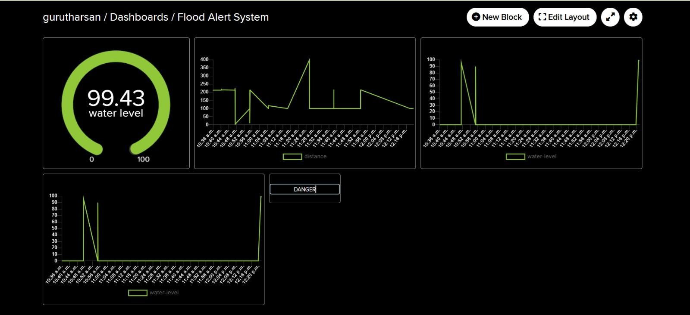
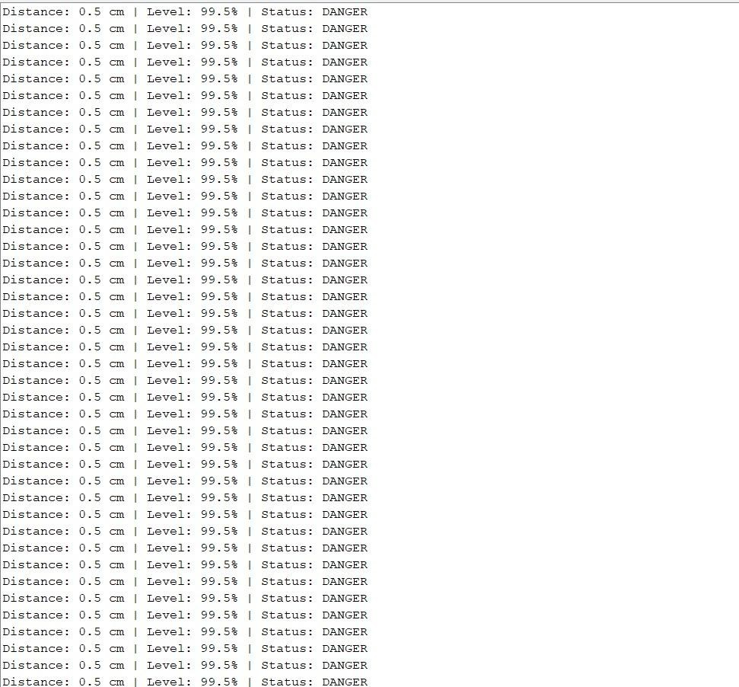

- Working sequence:
Water Surface → HC-SR04 Ultrasonic Sensor → Echo Signal Reception → Arduino Uno Processing → Water Level Calculation → Threshold Check → Green LED (Normal) / Yellow LED (Warning) / Red LED + Buzzer (Critical) → Continuous Monitoring
- Bill of Materials:
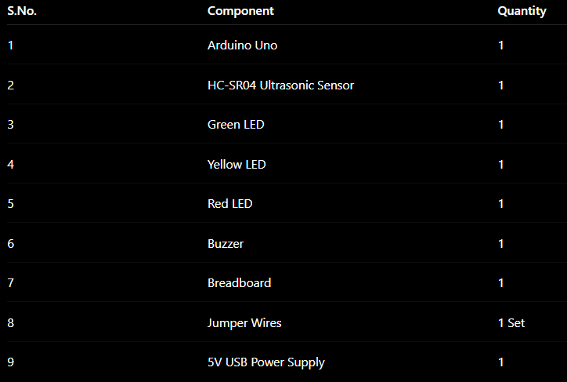

- Prototype Implementation:
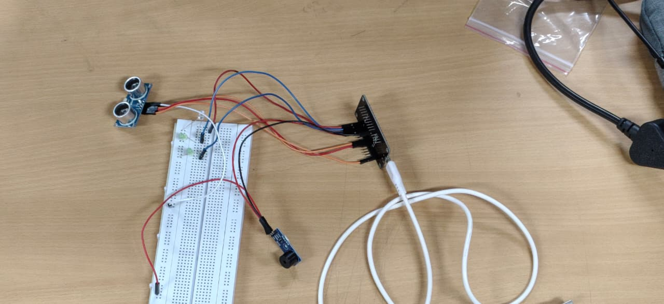

- Results and Performance Analysis:
Performance:
- Continuous Non-Contact Sensing
- Real-Time Threshold Monitoring
- Cloud & Remote Data Logging
- Factors Influencing Accuracy
Advantages:
- Non-Contact Measurement
- Low-Cost & Simple Design
- Multi-Level Early Alerting
- Remote Monitoring & Cloud Integration
- System Scalability
Limitations:
- Environmental & Surface Sensitivity
- Network & Internet Dependency
- Lack of Direct Automated Control
- Sensor Range & Precision Limits

